**LoRa Research**



*By: Johnson Domacasse (#4471709)*

*27 March 2024*

Contents

1. Introduction: 3

2. Methods: 3

3. Results: 3

4. Discussion: 4

5. Bibliography: 4

# Introduction:

The purpose of this research was to get us more acquainted with long distance protocols. LoRa is one of the many that fall under this category. LoRa is a low power, low cost, long range and secure communication protocol. It offers less data rate in return for a longer range. The LoRa protocol, functions on different frequencies, depending on where in the world you are. For example, in North-America the frequency is 915MHz while in Europe it is 868MHz. Its use cases range from metering, environment monitoring, tracking, and more.

A typical LoRa network is shown like figure 1. Here you would have your end devices/nodes on the left. These are connected to a gateway or concentrator to transport data to application sever via the networks server.

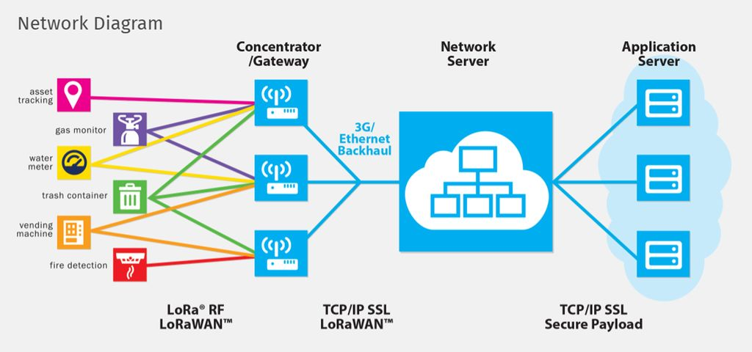

**Figure 1:** LoRa network diagram.

# Methods:

This research is done by creating a point to point communication between two LoRa devices. Some questions we want answered are how distance and obstacles can have an effect on the influence the communication**[1]**. The following tools were used for this research:

* 2X ESP32 LiLyGo TTGO LoRa MCUs (and their appropriate library for control)
* Platform IO in visual studio code.
* The LoRa library by Sandeep Mistry
* Provided sender and receiver code from GIT.

# Results:

After setting up the environment for both implementation and uploading both the sender and receiver code we begin inspecting it. We can see that the RSSI, a measurement of the power level of a radio frequency, changes each time it is further or closer to each other. Naturally, if I move the sender further away from the receiver, the RSSI would also decrease and the other way around if I move the sender closer to the receiver. After place a an obstacle (a notebook) in between them, I noticed that the RSSI significantly decreased. This leads me to believe that obstacles have an effect on the radio frequency level that is passing. This leads me to believe that environmental effects can have an effect on it. For example, when a storm is happening, it can have an effect on the frequency. I believe this makes the signal less strong but I have not tested this.

# Discussion:

The results show that obstacles have an effect on the radio frequency level that is passing. This also leads me to believe that environmental effects can have an effect on it. For example, when a storm is happening, it can have an effect on the frequency. I believe this makes the signal less strong but I have not tested this. This is strictly for LoRa and not other protocols that also use RSSI as a measurement unit. Wireless technologies are susceptible to signal degradation and interference from environmental factors, such as weather and terrain**[2]**.

# Bibliography:

**[1] –** Santos, S. (2019, October 19). *TTGO Lora32 SX1276 OLED with Arduino Ide*. Random Nerd Tutorials. <https://randomnerdtutorials.com/ttgo-lora32-sx1276-arduino-ide/>

**[2] -** *“*BenRhouma, O., Rebai, C., Ben-Romdhane, M., Di Cara, D., Artale, G., & Panzavecchia, N. (2023, December 5). *The environmental impacts of radio frequency and power line communication for advanced metering infrastructures in smart grids*. MDPI. <https://www.mdpi.com/1424-8220/23/24/9621#:~:text=However%2C%20wireless%20technologies%20are%20subject,weather%2C%20terrain%2C%20and%20foliage>.